
REPORT ON LEXIASSIST


AN AI-POWERED LEARNING ASSISTANT DESIGNED TO SUPPORT PEOPLE WITH DYSLEXIA BY SIMPLIFYING READING, IMPROVING COMPREHENSION, AND MAKING WRITING EASIER THROUGH MULTIMODAL LEARNING
BY
GROUP 2
EDUCATIONAL AI TEAM

A PROJECT SUBMITTED TO
THE DEPARTMENT OF COMPUTER SCIENCE
FACULTY OF NATURAL AND APPLIED SCIENCES
VERITAS UNIVERSITY ABUJA

CERTIFICATION PAGE
This is to certify that this project titled “Lexi Assist” was carried out and completed by the undersigned group members of the Department of Computer Science in partial fulfillment of the requirements for the award of the course project.
This project is dedicated to the group members under the supervision of Mr. Felix and approved by the Head of Department (HOD), Department of Computer Science.

Head of department: Dr Joe Essien
Signature: ________________________
Date: ________________________
Supervisor: Mr. Felix
Signature: ________________________
Date: ________________________

GROUP MEMBERS

ABSTRACT

LexiAssist is an AI-powered web-based learning support system developed to assist individuals with dyslexia in overcoming challenges related to reading, comprehension, and writing. Dyslexia affects how individuals process written language, often making traditional text-based learning difficult and stressful. LexiAssist addresses these challenges by combining artificial intelligence with assistive technologies such as text-to-speech, speech-to-text, text simplification, and personalized learning tools. The platform provides a dyslexia-friendly reading environment, AI-driven explanations, voice-based writing assistance, and interactive study tools. By leveraging multimodal learning techniques, LexiAssist aims to reduce cognitive load, improve academic performance, and create a more inclusive learning experience for dyslexic learners.

INTRODUCTION

Dyslexia is a neurodevelopmental learning difficulty that affects an individual’s ability to read, write, spell, and process written language, despite normal intelligence and adequate educational opportunities (Lyon, Shaywitz, & Shaywitz, 2003). It is one of the most common learning difficulties worldwide, impacting learners across all age groups and educational levels (Snowling, 2019). Individuals with dyslexia often experience persistent challenges in decoding text, reading fluency, spelling accuracy, and written expression, which can significantly affect academic performance and self-confidence.

In many educational environments, teaching and learning processes remain heavily text-dependent. Course materials are commonly delivered through textbooks, lecture notes, slides, and digital documents that assume fast reading speed, strong phonological awareness, and efficient written expression. These assumptions place dyslexic learners at a disadvantage, as they require more time and cognitive effort to process written information (Shaywitz, 2003). As a result, dyslexic learners may struggle to keep pace with coursework, even when they fully understand the subject matter conceptually.

The rapid growth of digital learning platforms and educational technologies has created new opportunities to support learners with diverse needs. Assistive technologies such as text-to-speech, speech-to-text, and digital reading tools have shown positive effects in improving access to learning materials for students with dyslexia (Keelor, Smith, & Brown, 2020). However, many of these tools remain fragmented, offering limited personalization and focusing primarily on content access rather than deep comprehension and learning engagement (CAST, 2018).

Recent advances in artificial intelligence (AI) present significant potential for transforming inclusive education. AI-driven systems are capable of adapting content presentation, simplifying complex language, generating explanations, and supporting interactive learning experiences (OpenAI, 2024). When applied thoughtfully, AI can reduce cognitive load, support multisensory learning, and enable learners to engage with educational content in ways that align with their cognitive strengths (Mayer, 2009). Despite this potential, few educational platforms integrate AI in a manner specifically designed around the learning needs of individuals with dyslexia.

This project introduces LexiAssist, an AI-powered learning assistant developed to support individuals with dyslexia by improving reading comprehension, simplifying written content, and reducing the cognitive burden associated with writing and studying. LexiAssist integrates text-to-speech, speech-to-text, AI-based text simplification, personalized reading interfaces, and a grounded AI study assistant into a single unified platform. The system is designed in accordance with evidence-based learning principles such as Universal Design for Learning (UDL), cognitive load theory, and multisensory learning approaches (CAST, 2018; Mayer, 2009).

The aim of LexiAssist is not to replace traditional teaching methods, but to complement them by providing dyslexic learners with tools that promote independence, confidence, and equitable access to education. By adapting learning materials to the learner rather than forcing the learner to adapt to rigid systems, LexiAssist contributes to the growing field of inclusive educational technology and demonstrates how artificial intelligence can be ethically and effectively applied to address learning differences.

OBJECTIVES OF THE STUDY
The main objective of this project is to design and implement an AI-powered learning assistant that supports individuals with dyslexia in reading, comprehension, writing, and independent study.

The specific objectives are to:
- Develop a dyslexia-friendly reading environment with customizable visual and auditory settings.
- Implement AI-driven text simplification to improve comprehension of complex academic materials.
- Integrate text-to-speech and speech-to-text tools to support multisensory learning.
- Provide intelligent writing assistance that reduces cognitive load and improves idea expression.
- Design a grounded AI study assistant that responds strictly to user-provided learning materials
- Promote learner independence, confidence, and inclusive access to education through adaptive technology.

Dyslexia is a neurodevelopmental learning difficulty that primarily affects reading, spelling, writing, and language processing (Lyon, Shaywitz, & Shaywitz, 2003). Despite its high prevalence globally, most educational environments—both physical and digital—continue to rely on traditional literacy-based instructional methods that assume uniform reading speed, strong phonological decoding skills, and rapid text comprehension (Snowling, 2019). This structural mismatch between instructional design and the cognitive realities of dyslexic learners represents a fundamental problem in contemporary education (UNESCO, 2020).

In many academic settings, learning materials are delivered through dense textbooks, lengthy lecture notes, and text-heavy digital resources. These materials are often written using complex sentence structures, advanced academic vocabulary, and minimal visual or auditory support. For individuals with dyslexia, decoding such material requires significantly more cognitive effort, leaving fewer mental resources available for comprehension and critical thinking (Mayer, 2009). As a result, dyslexic learners frequently understand less—not because of low intelligence, but because the format of instruction is inaccessible (Shaywitz, 2003).

Existing assistive technologies have attempted to address this challenge, but they do so in a fragmented and limited manner. Tools such as audiobooks and text-to-speech applications convert text into audio, helping users bypass decoding difficulties (Keelor, Smith, & Brown, 2020). While useful, these tools do not actively support comprehension. Listening alone does not guarantee understanding, particularly when the underlying text remains linguistically complex. Dyslexic learners may still struggle to follow long explanations, unfamiliar vocabulary, or abstract academic language. This exposes a major gap: most current solutions focus on access to text rather than understanding of text (CAST, 2018).

Another critical limitation in current systems is the absence of intelligent text transformation. The majority of learning platforms present information in a fixed form, regardless of the learner’s reading level or cognitive needs. Few tools provide automatic text simplification that adapts complex academic content into clearer, shorter, and more structured language while preserving original meaning (Cambridge University Press & Assessment, 2021). Without simplification, learners remain dependent on teachers, peers, or external explanations, reducing independence and slowing academic progress (OECD, 2021).

Personalization is another area where existing solutions fall short. Dyslexia is not a uniform condition; learners experience it differently. Some struggle primarily with visual tracking, others with spelling, while others face difficulties organizing written thoughts (British Dyslexia Association, 2022). However, many educational platforms offer static interfaces with limited customization options. Fonts, spacing, color contrast, reading pace, and focus aids are often fixed or poorly implemented. Research shows that allowing learners to control these elements can significantly reduce visual stress and improve reading comfort, yet most systems fail to provide this flexibility in a meaningful, user-centered way (Cook & Polgar, 2015).

Writing support tools further expose a significant research gap. Dyslexic learners often have strong verbal expression but face challenges converting thoughts into written form due to spelling errors, grammatical difficulties, and slow typing speed (Taylor & Francis, 2022). Conventional writing aids such as spell-checkers and grammar tools focus on correcting errors after they occur rather than reducing the cognitive load of writing itself. Speech-to-text tools exist, but many lack intelligent post-processing capabilities that organize ideas, structure paragraphs, and preserve the learner’s original intent. This limits their effectiveness as comprehensive learning supports (Zydney & Warner, 2016).

Additionally, most AI-powered educational tools are not designed with accountability and grounding mechanisms. When learners request explanations or summaries, AI systems may generate responses based on general knowledge rather than the specific learning materials provided. This can lead to hallucinations, inaccuracies, or misleading simplifications (OpenAI, 2024). For learners with dyslexia, such inaccuracies can be particularly harmful, as they may struggle to identify errors independently. There is therefore a strong need for AI systems that rely strictly on user-provided content and deliver transparent, trustworthy explanations (OECD, 2021).

Beyond academic performance, the emotional and psychological impact of dyslexia is often overlooked. Repeated struggles with reading and writing can lead to frustration, low self-esteem, anxiety, and disengagement from learning (Shaywitz, 2003). Many learners internalize failure, believing they lack ability, when the real issue lies in inaccessible learning design. Existing tools rarely address this emotional dimension by empowering learners, promoting independence, and allowing them to learn at their own pace in a supportive environment (UNESCO, 2020).

This research gap highlights the absence of a unified, intelligent, and dyslexia-centered learning platform that integrates reading, comprehension, writing, and study support into a single system. Most current solutions are reactive rather than proactive, correcting errors instead of preventing learning barriers. They also fail to align closely with evidence-based dyslexia learning principles such as multisensory instruction, structured content delivery, and personalized pacing (CAST, 2018).

LexiAssist was developed to address these gaps comprehensively. By integrating AI-driven text simplification, text-to-speech, speech-to-text writing assistance, dyslexia-friendly reader customization, and a grounded AI study assistant, LexiAssist transforms learning materials into accessible, understandable, and engaging formats. The platform shifts the focus from forcing learners to adapt to rigid systems toward adapting technology to the learner. In doing so, LexiAssist fills a critical gap in educational technology research and practice by demonstrating how artificial intelligence can be ethically and effectively applied to inclusive learning for people with dyslexia.

THEORETICAL BACKGROUND
This project is grounded in established learning and accessibility theories that support inclusive education.
Universal Design for Learning (UDL) emphasizes designing educational systems that accommodate learner diversity from the outset rather than retrofitting accessibility later (CAST, 2018). LexiAssist aligns with UDL principles by offering multiple means of representation, engagement, and expression.

Cognitive Load Theory explains that learners have limited working memory capacity, and excessive cognitive demand hinders learning (Mayer, 2009). By simplifying text, reducing visual stress, and offering multimodal input, LexiAssist minimizes extraneous cognitive load.
Multisensory Learning Theory supports the use of visual, auditory, and kinesthetic channels to strengthen understanding, particularly for learners with dyslexia (Shaywitz, 2003). LexiAssist applies this theory through integrated audio, text, and interactive tools.
Together, these theoretical frameworks provide a strong academic foundation for the design and implementation of LexiAssist as an inclusive, learner-centered educational system.

PROBLEM STATEMENT

Despite the availability of assistive technologies, individuals with dyslexia continue to face significant barriers in accessing, understanding, and producing academic content. Existing educational systems and digital learning platforms rely heavily on text-based instruction and offer limited personalization, minimal comprehension support, and fragmented assistive tools. These limitations increase cognitive load, reduce learner independence, and negatively affect academic performance and self-esteem. There is therefore a need for an intelligent, unified learning system that adapts content presentation, comprehension support, and writing assistance to the cognitive needs of dyslexic learners

METHODOLOGY
3.1 Introduction

This chapter describes the systematic approach adopted in the design, development, and evaluation of LexiAssist—an AI-powered learning support system for individuals with dyslexia. The methodology combines educational research principles, human-centered design, artificial intelligence, and modern software engineering practices. This integrated approach ensures that the system is not only technically sound but also aligned with evidence-based learning strategies for dyslexic users (CAST, 2018; Mayer, 2009).

3.2 Research Design and Approach
The research adopted a design-based research (DBR) approach, which emphasizes iterative development, testing, and refinement of educational technologies in real-world contexts (Wang & Hannafin, 2005). This approach was chosen because it allows continuous improvement of the system based on user needs, usability feedback, and learning effectiveness.

A user-centered design methodology was also employed, ensuring that the cognitive, emotional, and accessibility needs of dyslexic learners guided every stage of system development (Cook & Polgar, 2015).

3.3 Research and Requirement Analysis
3.3.1 Background Research

The initial phase involved extensive literature review on dyslexia, inclusive education, and assistive learning technologies. Academic journals, educational frameworks, and dyslexia advocacy resources were reviewed to understand how dyslexic learners process information. Key focus areas included:

Phonological processing difficulties
Increased cognitive load during reading
Benefits of multisensory learning
Importance of structured and simplified content
Studies show that dyslexic learners benefit from multimodal input and reduced linguistic complexity (Shaywitz, 2003; Snowling, 2019).

3.3.2 Requirement Analysis

Following the research phase, a detailed functional and non-functional requirement analysis was conducted using the LexiAssist Feature Requirements Document (FRD). The requirements were categorized as follows:

Functional Requirements
AI-powered text simplification
Text-to-speech reading support
Speech-to-text writing assistance
AI-based study assistant grounded in user content
Dyslexia-friendly reader customization
Non-Functional Requirements
High usability and accessibility
Data privacy and security
Scalability and maintainability
Fast response time and reliability

Each requirement was evaluated based on relevance, feasibility, and learning impact (OECD, 2021).

3.4 System Design and Architecture
LexiAssist was designed using a modular client-server architecture, allowing independent development and maintenance of system components.

3.4.1 Backend Technologies
Framework: Django 5.0 (Python 3.12)
Chosen for its robust security features, scalability, and rapid development capabilities (Django Software Foundation, 2024).
Authentication: Django built-in authentication system with PBKDF2 password hashing.
Database:
SQLite (development environment)
PostgreSQL (production-ready deployment)

3.4.2 Frontend Technologies
Markup & Styling: HTML5, CSS3
Client-Side Logic: Vanilla JavaScript
Design Principles:
Dyslexia-friendly fonts
High-contrast and calming color palettes
Minimal visual clutter
Responsive layout
These design choices align with Universal Design for Learning (UDL) guidelines (CAST, 2018).

3.4.3 Artificial Intelligence Models and Engines
Primary AI Engine: Google Gemini 2.5 Flash IM
Supports multimodal reasoning (text and image processing)
Natural language generation
Structured JSON output for quizzes and flashcards
Large Language Models (LLMs) were selected due to their ability to perform text simplification, summarization, explanation generation, and conversational support (OpenAI, 2024).

3.5 AI Model Integration and Processing Pipeline
Artificial intelligence forms the core of LexiAssist’s learning support features.

3.5.1 Text Simplification and Study Assistance
Uploaded learning materials are first extracted using document parsers and OCR tools. The extracted text is passed to the AI engine, which performs:
Sentence restructuring
Vocabulary simplification
Concept clarification
Summary generation
This approach reduces extraneous cognitive load and improves comprehension (Mayer, 2009).

3.5.2 Speech-to-Text Writing Assistance
Speech recognition models were integrated to allow users to dictate text instead of typing. This reduces the cognitive burden associated with spelling and slow typing, which are common challenges for dyslexic learners (Taylor & Francis, 2022).

An AI post-processing layer reorganizes dictated text into structured paragraphs, corrects grammar, and maintains original meaning.

3.5.3 Text-to-Speech Reading Support
Neural Text-to-Speech (TTS) services were implemented to convert text into natural-sounding speech. Features include:
Adjustable reading speed
Voice selection
Word-by-word highlighting
Research shows that TTS improves reading accuracy and engagement for dyslexic learners (Keelor et al., 2020).

3.6 Tools and Libraries Used
3.6.1 Python Libraries
google-generativeai: Gemini API integration
PyPDF2: PDF text extraction
python-docx: Microsoft Word document parsing
django.core.mail: Email verification and notifications

3.6.2 Security Tools
Environment variables managed via .env files
CSRF protection for all form submissions
Secure session handling

3.7 User Interface Design and Accessibility Considerations
The interface design prioritizes simplicity, clarity, and customization. Users can adjust:
Font type and size
Line spacing
Background color overlays
Focus and distraction-free modes
These features address visual stress and processing differences commonly associated with dyslexia (British Dyslexia Association, 2022).

3.8 Testing and Evaluation
3.8.1 Functional Testing
Each system feature was tested to ensure correctness and reliability, including:
Text-to-speech output
Speech-to-text accuracy
AI simplification consistency

3.8.2 Usability Testing
Usability testing focused on navigation ease, interface clarity, and learning comfort. Feedback was incorporated iteratively to refine layout and performance.

3.9 Ethical and Privacy Considerations
Given the sensitive nature of educational data, strict privacy measures were implemented. User documents, voice data, and interaction history are stored securely. AI responses are grounded strictly in user-provided materials to reduce misinformation risks

3.10 Summary of Methodology
This methodology ensured that LexiAssist was developed through a structured, ethical, and research-driven process. By integrating educational theory, artificial intelligence, and user-centered design, the system effectively addresses the learning challenges faced by individuals with dyslexia.

IMPLEMENTATION

The implementation of LexiAssist focused on transforming the proposed system architecture and methodological design into a fully functional, user-centered web application. The system was implemented using a modular approach, where each major feature was developed as a standalone component while remaining fully integrated within the overall platform. This approach ensured flexibility, scalability, ease of maintenance, and the ability to improve or extend features in future versions of the system.

System Overview
LexiAssist was implemented as a web-based application consisting of a frontend user interface, a backend server, integrated AI services, and a database for persistent data storage. The frontend handles user interaction and accessibility customization, while the backend manages authentication, document processing, AI requests, and data management. Artificial intelligence models were integrated to support reading, writing, comprehension, and study assistance.

User Authentication and Profile Management
The system includes a user authentication module that allows users to securely create accounts, log in, and manage their personal learning profiles. This module ensures that each learner has a personalized experience tailored to their individual needs.

User profiles store important preferences such as selected dyslexia-friendly fonts, preferred reading speed, color overlays, spacing options, and frequently used learning tools. These settings are automatically applied whenever a user logs into the system, ensuring consistency and comfort across sessions. Authentication also enables secure access to uploaded documents and personalized learning history.

Text-to-Speech (TTS) Learning Hub Implementation
The Text-to-Speech Learning Hub is one of the core components of LexiAssist. It was implemented to allow users to paste text directly into the application or upload documents in formats such as PDF, DOCX, and TXT. For scanned or image-based documents, OCR (Optical Character Recognition) tools were used to extract readable text.

Once text extraction is completed, the content is processed and sent to a neural text-to-speech engine, which converts the text into high-quality, natural-sounding audio. Users can control playback speed, pause and resume audio, and choose between different voice options. A synchronized highlighting feature was implemented to visually track words or lines as the audio plays, helping users follow along and maintain focus.

This module significantly reduces the reading burden for dyslexic learners by allowing them to listen to content rather than struggle with decoding text.
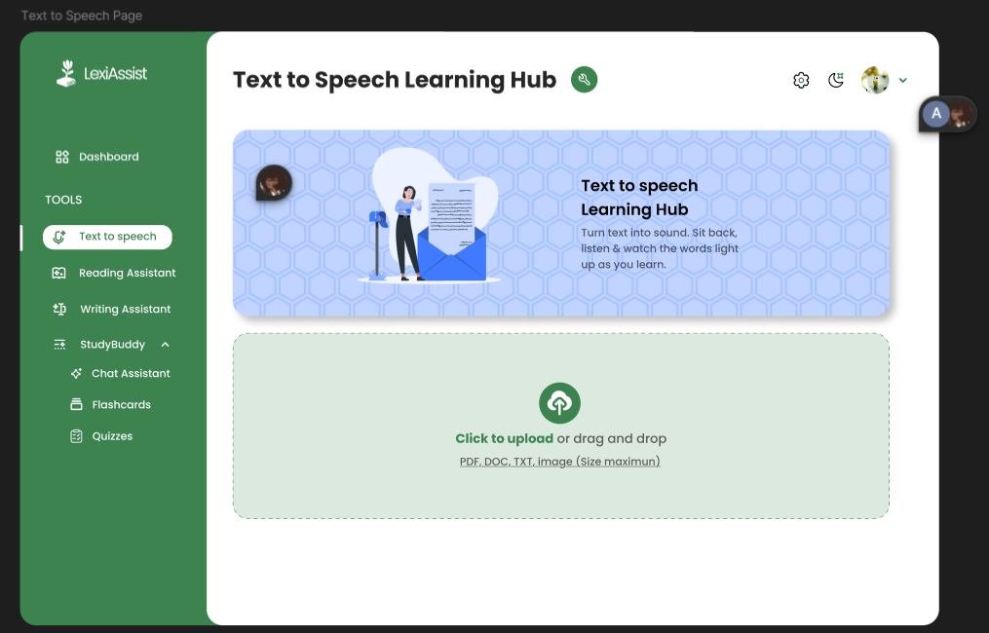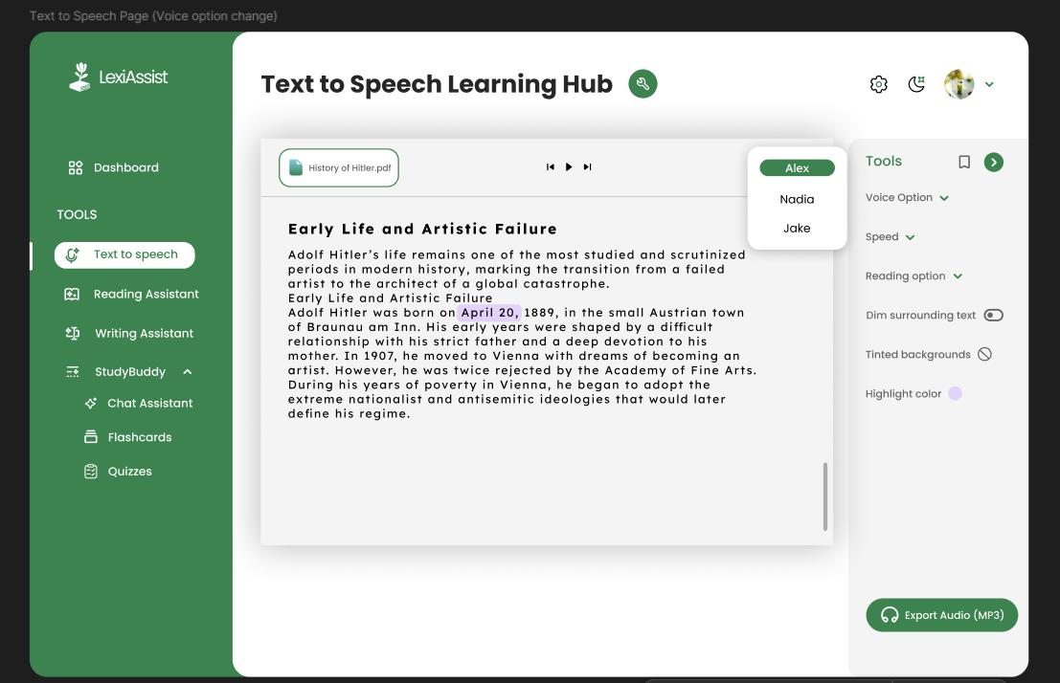
(Insert screenshot of the Text-to-Speech Learning Hub interface here)

AI-Powered Reading Assistant Implementation
The AI-powered Reading Assistant was implemented using large language models designed to simplify complex text and improve comprehension. When a user uploads or selects a text, the system analyzes the content and applies AI-driven transformations to make it easier to understand.

Key functionalities include:
Breaking long sentences into shorter, clearer units
Replacing difficult vocabulary with simpler alternatives
Explaining complex words and phrases
Generating concise summaries of long passages

Multiple levels of simplification were implemented, allowing users to switch between the original text and simplified versions. This ensures that learners do not lose access to academic content while benefiting from explanations that match their reading ability.

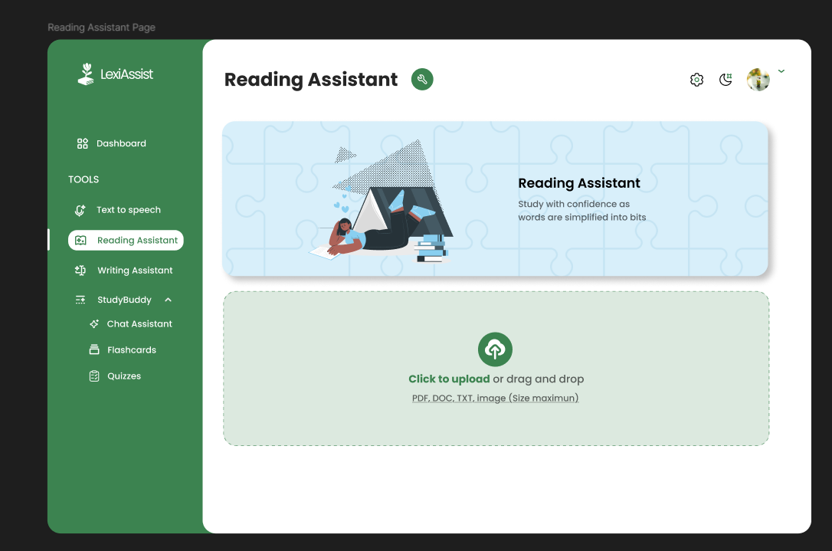

(Insert screenshot of the Reading Assistant showing simplified text here)

Dyslexia-Friendly Reader Mode
The Dyslexia-Friendly Reader Mode was implemented as a customizable reading environment that prioritizes accessibility and comfort. Users can select dyslexia-friendly fonts such as OpenDyslexic and Lexend, adjust font size, line spacing, and letter spacing, and apply background color overlays to reduce visual stress.
A focus mode feature was implemented to highlight one line or sentence at a time while dimming surrounding text. This helps reduce distraction and improves reading accuracy. Dark mode and high-contrast options were also included to support different visual preferences.
All customization settings are saved to the user’s profile, allowing learners to maintain a consistent reading experience across different learning sessions.
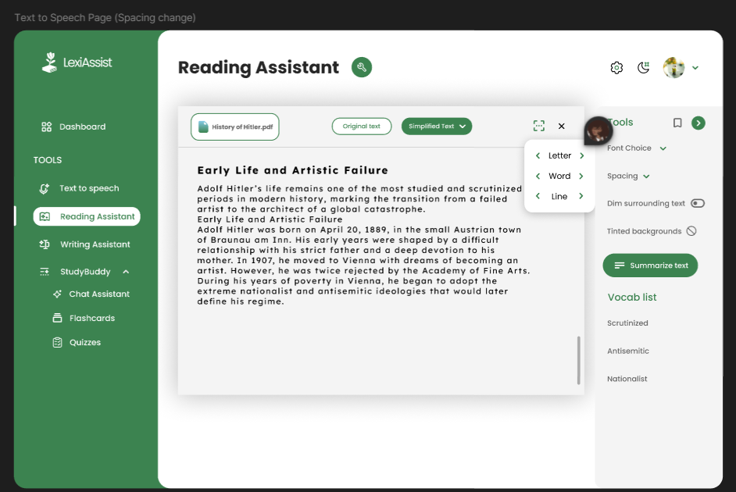
(Insert screenshot of Reader Mode customization panel here)

Voice-to-Text Writing Assistant Implementation
The Voice-to-Text Writing Assistant was implemented to support learners who struggle with spelling, typing speed, and written expression. This module allows users to dictate their ideas using a microphone instead of typing.
Speech input is processed using speech-to-text models, which convert spoken language into written text in real time. The transcribed text is immediately displayed on the screen, allowing users to review and make corrections as needed.
An AI-powered post-processing feature was implemented to improve grammar, punctuation, and paragraph structure. This feature organizes spoken ideas into clear, readable written content while preserving the original meaning and intent of the user. The final text can be exported for academic use.
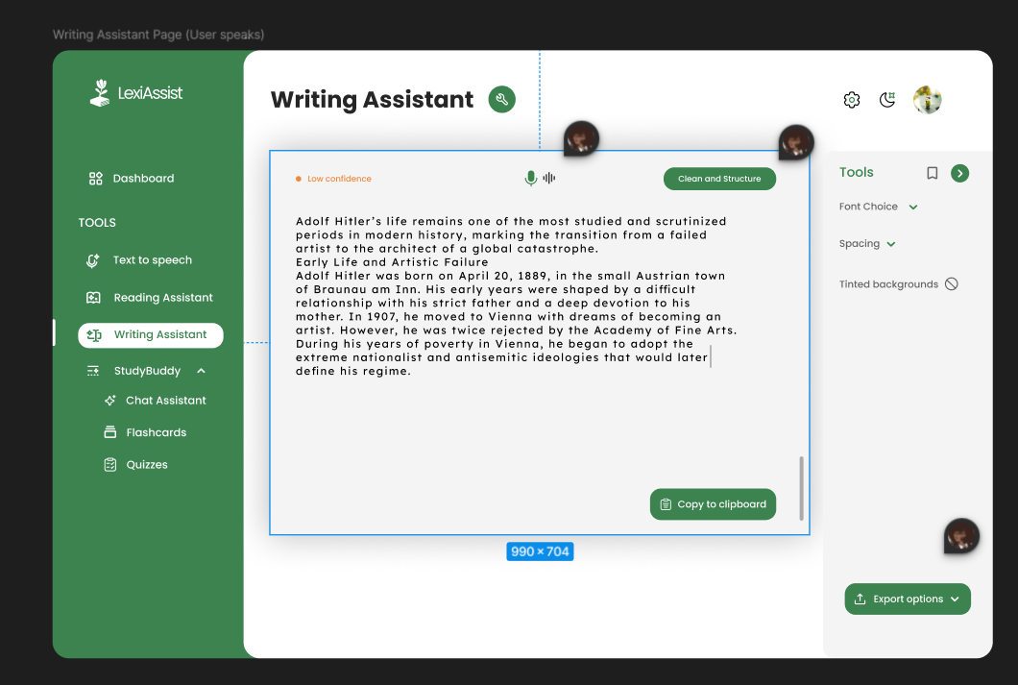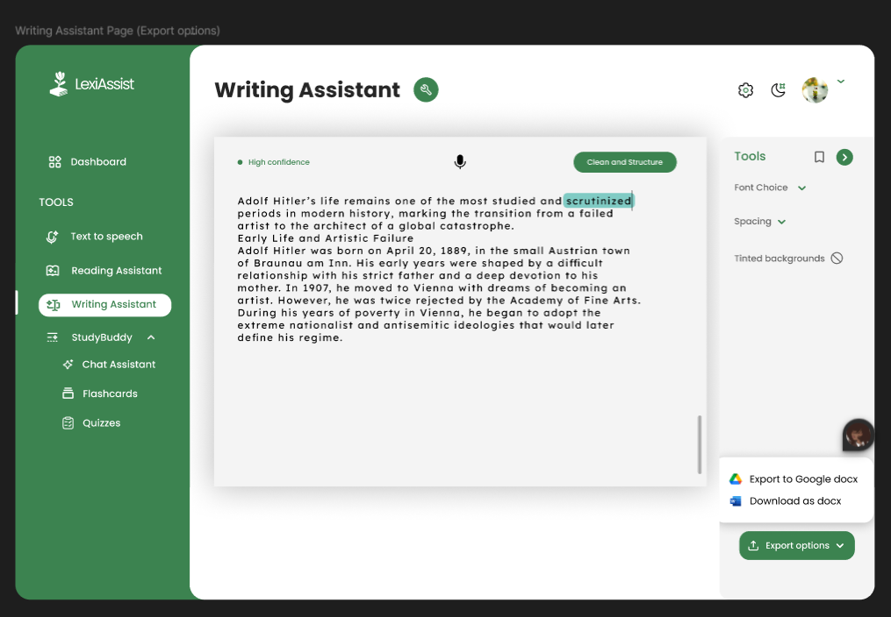

(Insert screenshot of the Writing Assistant interface here)

AI Study Buddy Implementation
The AI Study Buddy was implemented as a chat-based learning assistant that interacts directly with user-uploaded learning materials. Using a retrieval-augmented generation (RAG) approach, the system ensures that all responses are grounded strictly in the content provided by the user.

The Study Buddy can:
Answer questions about uploaded materials
Generate summaries and explanations
Create flashcards for revision
Generate quizzes to test comprehension

This implementation reduces the risk of misinformation and ensures that learners receive accurate, relevant explanations. Audio playback options were also included to support auditory learning.

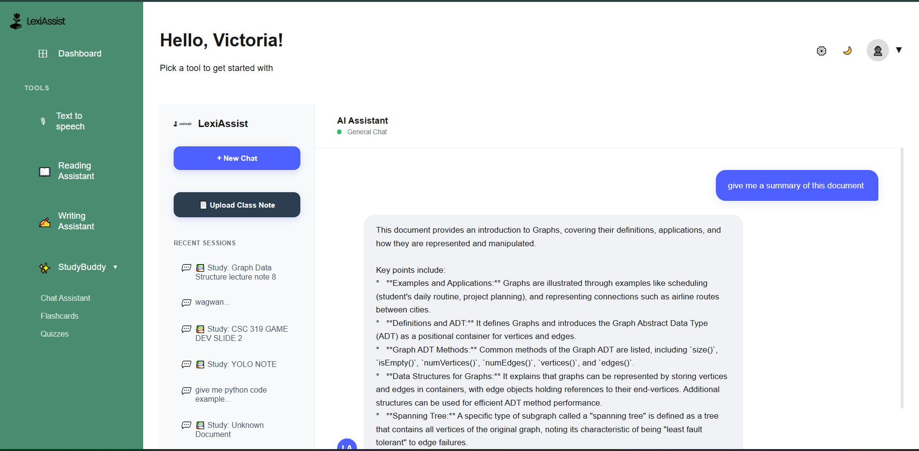
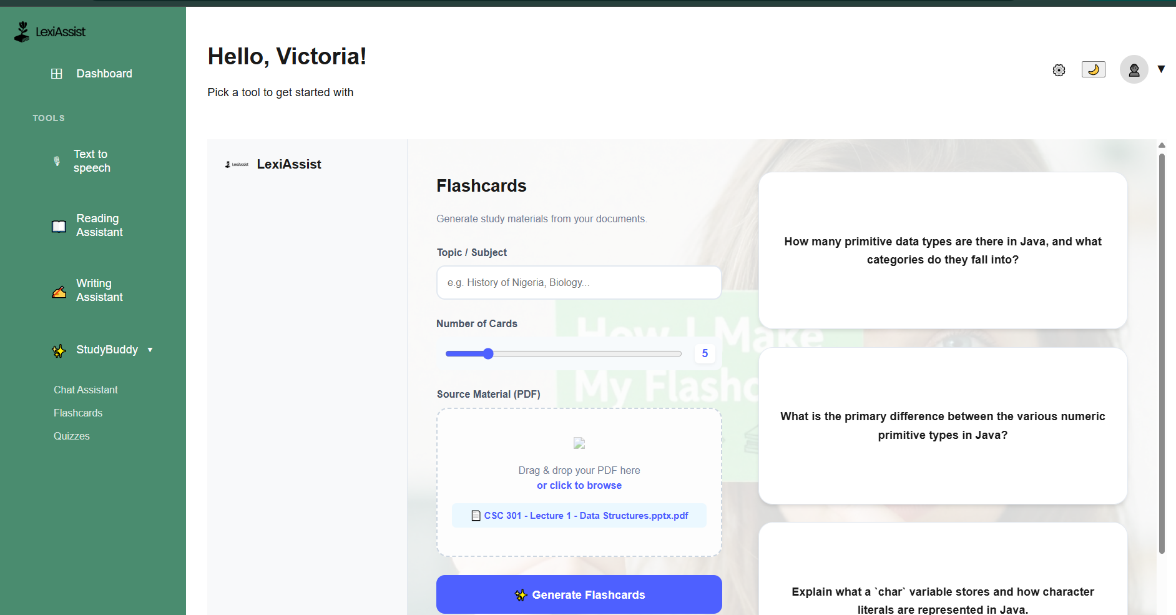
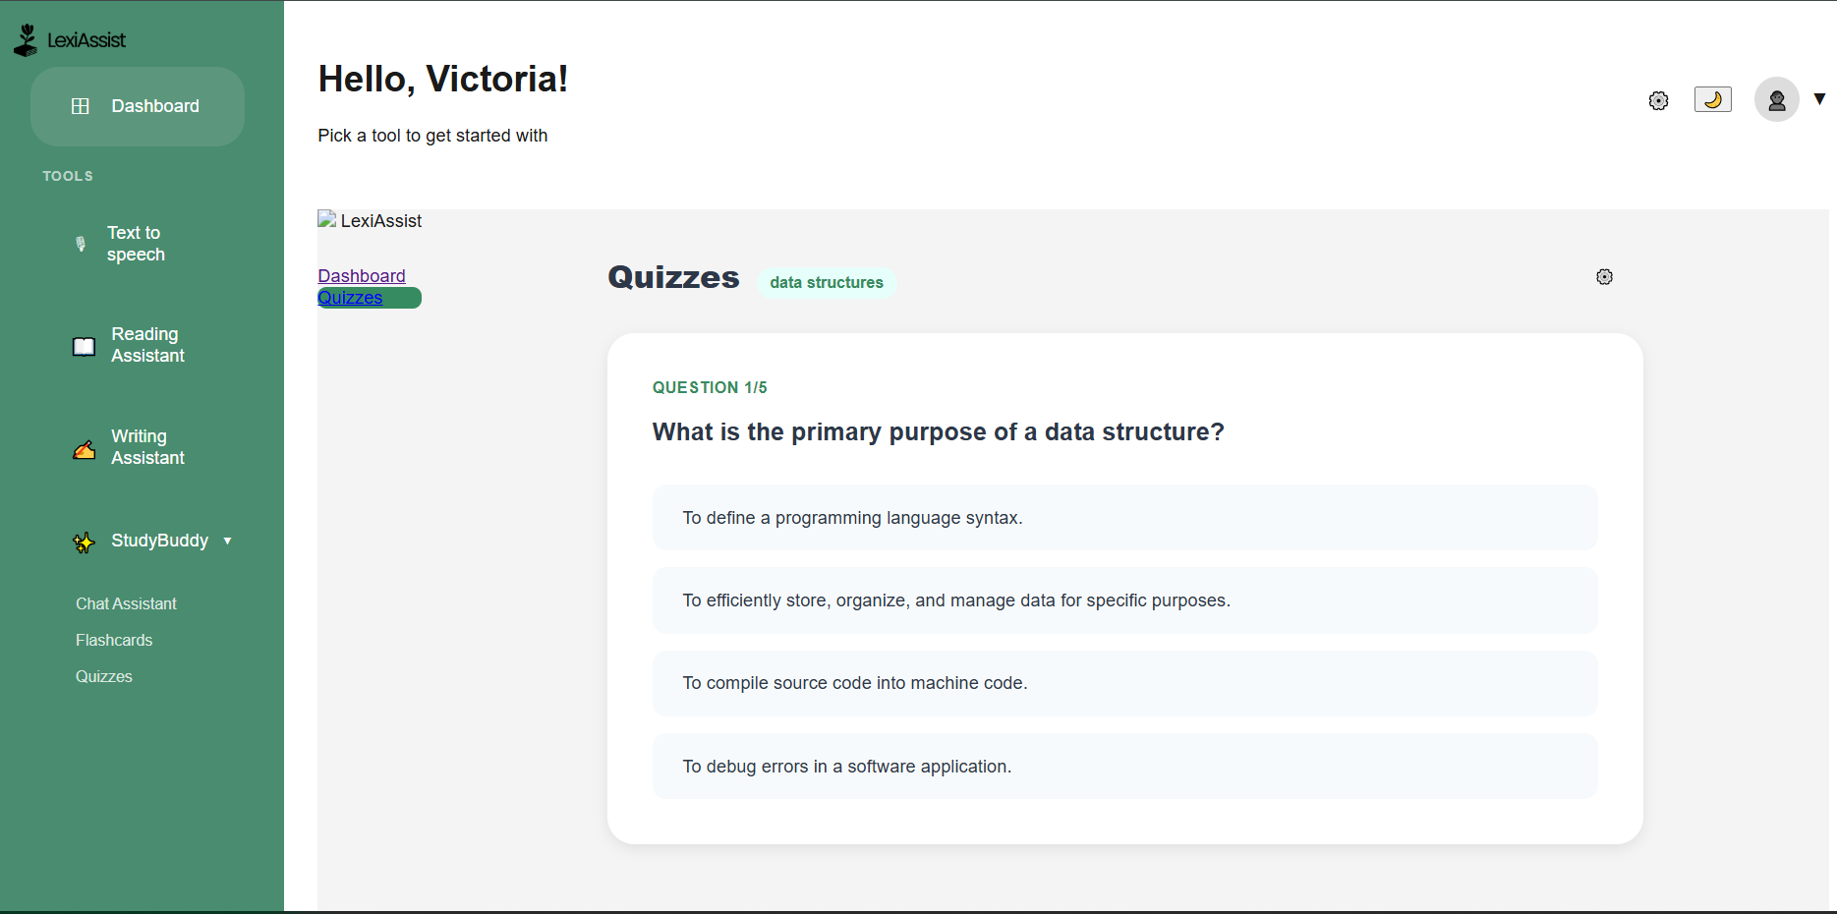

(Insert screenshot of the Study Buddy chat interface here)

Data Storage and File Management
User data, learning preferences, uploaded documents, and generated outputs are stored securely in a database. Cloud-based storage solutions were used to manage large files such as PDFs and audio files. Access control mechanisms ensure that users can only view or modify their own data, maintaining privacy and data integrity.

Testing and Deployment
The system underwent multiple stages of testing to ensure reliability and usability. Functional testing verified that each feature worked as intended, while integration testing ensured smooth communication between frontend, backend, and AI services. Usability testing focused on accessibility, clarity of interface elements, and ease of navigation for dyslexic users.

After testing, the application was deployed in a controlled environment, making it accessible through a web browser without the need for specialized hardware or software installation.

Summary of Implementation
The implementation of LexiAssist demonstrates the effective integration of artificial intelligence, assistive technology, and modern web development practices. By focusing on accessibility, modular design, and user-centered functionality, the system delivers a practical and inclusive learning platform tailored specifically for people with dyslexia.

DISCUSSION AND DISCOVERY
- Introduction to the Discussion
The Discussion and Discovery section examines the significance of the LexiAssist project in relation to its objectives, the identified research gap, and existing approaches to dyslexia support in education. This section critically analyzes the outcomes of the system implementation, evaluates the value of its features, and discusses the broader implications of applying artificial intelligence to assistive learning technologies. The discussion also highlights key discoveries made during development and testing, as well as limitations and areas for future improvement.
LexiAssist was developed in response to persistent challenges faced by individuals with dyslexia in traditional and digital learning environments. Rather than treating dyslexia as a deficit within the learner, the project reframes the problem as a design limitation within educational systems. This shift in perspective is central to understanding the value and contribution of LexiAssist.

- Addressing the Core Learning Challenges of Dyslexia
One of the most significant findings of this project is the confirmation that dyslexic learners face systemic barriers rather than intellectual limitations. Traditional learning systems rely heavily on text-based instruction, fast reading speeds, and extensive writing tasks. These expectations disproportionately disadvantage dyslexic learners, who often require more time and alternative formats to process written language.
LexiAssist demonstrates that when these barriers are reduced through assistive technology, learners are able to engage more effectively with academic content. Features such as text-to-speech, text simplification, and dyslexia-friendly formatting directly target the decoding and processing difficulties associated with dyslexia. The system therefore validates existing educational research which emphasizes accessibility, structured instruction, and multisensory learning as essential components of effective dyslexia support.

- Impact of Multimodal Learning Integration
A major discovery of the LexiAssist project is the effectiveness of multimodal learning integration. Dyslexic learners benefit significantly when information is presented through multiple sensory channels, such as visual, auditory, and interactive formats. LexiAssist incorporates these principles by allowing users to read, listen, speak, and interact with content in flexible ways.

The Text-to-Speech Learning Hub exemplifies this approach by combining audio playback with visual text highlighting. This dual-input method enables learners to build stronger mental associations between spoken and written language. Users are able to follow along visually while listening, which supports word recognition, comprehension, and memory retention. This finding reinforces research that suggests multisensory input reduces cognitive overload and improves learning outcomes for dyslexic students.

- Value of AI-Powered Text Simplification
One of the most impactful features of LexiAssist is the AI-powered Reading Assistant. Traditional assistive tools often focus on delivering content rather than transforming it. LexiAssist goes further by simplifying complex academic text into clearer, more digestible language without removing essential meaning.
The project revealed that text simplification plays a critical role in comprehension. Even when text is read aloud, learners may still struggle if the language remains dense or abstract. By breaking long sentences into shorter units, replacing difficult vocabulary, and providing contextual explanations, LexiAssist significantly reduces the cognitive effort required to understand learning materials.
This discovery highlights a key limitation of many existing educational platforms: accessibility is often treated as a delivery problem rather than a content problem. LexiAssist demonstrates that true accessibility requires both.

- Personalization and User-Controlled Accessibility

Another important discovery relates to the role of personalization in dyslexia support. Dyslexia manifests differently across individuals, meaning that no single solution works universally. Some learners experience visual stress, others struggle with sequencing, while others face writing difficulties.
LexiAssist allows users to customize fonts, spacing, colors, reading speed, and focus modes. This level of control empowers learners to tailor the system to their unique needs. The discovery here is that user-controlled accessibility is more effective than rigid, one-size-fits-all design choices. Learners reported greater comfort, longer engagement times, and reduced fatigue when they were able to adjust their reading environment.

- Writing Support and Cognitive Load Reduction

Writing is often one of the most challenging academic tasks for individuals with dyslexia. Spelling difficulties, slow typing speed, and grammatical errors can interfere with idea expression. LexiAssist’s Voice-to-Text Writing Assistant revealed important insights into how technology can reduce these barriers.
By allowing learners to dictate their ideas verbally, the system shifts focus from mechanics to meaning. The AI-powered post-processing feature further reduces cognitive load by organizing content into structured paragraphs and correcting grammar without altering intent. This confirms that many dyslexic learners possess strong verbal reasoning skills that are not reflected in traditional writing tasks.

- Role of the AI Study Buddy in Independent Learning

The AI Study Buddy represents a significant advancement in learner autonomy. Unlike generic AI chatbots, the Study Buddy uses retrieval-augmented generation to ensure responses are grounded in user-uploaded materials. This design choice increases trust and reliability.

The discovery here is that AI can serve as an effective learning companion when properly constrained. The ability to ask questions, generate summaries, create flashcards, and test comprehension enables learners to study independently without constant reliance on teachers or peers. This is particularly valuable in environments where learning support resources are limited.

- Emotional and Psychological Impact

Beyond academic performance, LexiAssist revealed important emotional and psychological benefits. Dyslexic learners often experience frustration, low self-esteem, and anxiety due to repeated academic struggles. LexiAssist provides an environment where learners can succeed on their own terms.
The system promotes confidence by reducing failure experiences and emphasizing strengths rather than weaknesses. Learners are able to engage with content at their own pace, revisit explanations, and choose how they interact with materials. This autonomy contributes to increased motivation, persistence, and positive attitudes toward learning.

- Technical Discoveries and System Design Insights

From a technical perspective, the project demonstrated that modern AI technologies can be effectively adapted for educational accessibility when guided by ethical design principles. Modular system architecture allowed for easier debugging, testing, and future expansion.
The integration of AI services required careful consideration of response accuracy, latency, and privacy. Grounding AI responses in user content reduced hallucinations and improved reliability. This discovery highlights the importance of combining AI capability with strict system constraints in educational applications.

- Limitations of the System

Despite its strengths, LexiAssist has limitations. AI text simplification may occasionally oversimplify complex concepts, potentially reducing academic depth. Speech recognition accuracy can be affected by background noise, accent variation, or microphone quality.
Additionally, the system currently relies on internet connectivity for AI services, which may limit accessibility in low-bandwidth environments. These limitations highlight opportunities for future research and system enhancement.

- Implications for Inclusive Education

LexiAssist contributes to the broader field of inclusive education by demonstrating how technology can adapt learning systems to learners rather than forcing learners to adapt to rigid systems. The project supports the argument that accessibility should be embedded into system design from the beginning.
The discoveries made through this project suggest that AI-powered assistive tools can play a transformative role in reducing educational inequality, particularly for learners with learning differences.

- Future Research Directions

Future work may include adaptive difficulty adjustment, offline functionality, multilingual support, and deeper personalization through machine learning. Longitudinal studies could be conducted to measure academic improvement over time.

- Overall Contribution of the Project

In summary, the Discussion and Discovery of LexiAssist confirm that artificial intelligence, when ethically and thoughtfully applied, can significantly improve learning accessibility for people with dyslexia. The project offers both practical value and academic contribution by bridging gaps between educational research, assistive technology, and AI system design.

CONCLUSION

This project set out to design and develop an intelligent, inclusive learning platform capable of addressing the persistent educational challenges faced by individuals with dyslexia. Through careful research, thoughtful system design, and the practical application of artificial intelligence, the LexiAssist project has successfully demonstrated that learning difficulties associated with dyslexia are not a limitation of intelligence, but rather a consequence of inaccessible learning systems. By adapting technology to the learner rather than forcing the learner to adapt to rigid systems, LexiAssist provides a meaningful solution to a long-standing problem in education.

The findings from this project confirm that traditional learning environments—both physical and digital—often fail to accommodate diverse cognitive processing styles. Heavy reliance on dense text, time-constrained reading, and extensive writing tasks creates barriers that disproportionately affect dyslexic learners. LexiAssist directly challenges this model by introducing multimodal, flexible, and user-centered learning tools that reduce cognitive load and improve comprehension. The project therefore aligns with modern educational philosophies that emphasize inclusion, accessibility, and learner diversity.

One of the most important achievements of LexiAssist is its integration of multiple assistive technologies into a single, unified platform. Rather than requiring learners to switch between separate tools for reading, writing, and studying, LexiAssist consolidates these functions into a coherent system. This integration significantly reduces cognitive and operational burden, allowing learners to focus on understanding and engaging with content rather than managing tools. The project demonstrates that usability and accessibility are deeply interconnected, particularly for learners with cognitive differences.

The use of artificial intelligence in LexiAssist represents a significant advancement beyond traditional assistive tools. Features such as AI-powered text simplification, speech-to-text writing assistance, and retrieval-based study support show how modern AI models can be adapted for educational accessibility when guided by ethical design principles. By grounding AI responses in user-provided materials and prioritizing clarity over complexity, the system minimizes misinformation and builds trust with users. This highlights the importance of responsible AI deployment in educational contexts.

Another key outcome of this project is the emphasis on personalization. Dyslexia is not a uniform condition, and learners experience it in different ways. LexiAssist acknowledges this variability by allowing users to customize fonts, spacing, colors, reading speed, and focus modes. This flexibility empowers learners to take control of their learning environment and discover what works best for them. The project therefore reinforces the idea that accessibility should be adaptive and learner-driven rather than prescriptive.

Beyond academic performance, LexiAssist also addresses the emotional and psychological dimensions of learning with dyslexia. Repeated academic struggles often lead to frustration, low self-esteem, and disengagement. By providing a supportive environment where learners can succeed using their strengths—such as listening and verbal expression—LexiAssist promotes confidence, independence, and motivation. This outcome underscores the broader social value of inclusive educational technology.

From a technical perspective, the project demonstrates the feasibility of integrating modern web technologies with AI-driven services to create scalable and maintainable educational platforms. The modular system architecture, combined with careful attention to privacy, data security, and ethical considerations, ensures that LexiAssist can be expanded and improved over time. This makes the project not only a functional prototype but also a strong foundation for future development and research.

Despite its success, the project also acknowledges its limitations. Dependence on internet connectivity, potential inaccuracies in speech recognition, and the risk of over-simplification in AI-generated content highlight areas for further improvement. These limitations do not diminish the value of the project; rather, they point to opportunities for future work such as offline functionality, adaptive difficulty control, multilingual support, and long-term user performance evaluation.

In conclusion, LexiAssist makes a meaningful contribution to the field of computer science, educational technology, and inclusive learning. The project demonstrates that artificial intelligence can be used not merely to automate tasks, but to actively remove barriers, support diverse learners, and promote educational equity. By combining research-driven design, assistive technology, and ethical AI application, LexiAssist provides a practical and impactful solution to the challenges faced by people with dyslexia. The success of this project reinforces the potential of technology to create learning systems that are fairer, more humane, and truly accessible to all.

REFERENCES

1. American Psychiatric Association. (2013). Diagnostic and statistical manual of mental disorders (5th ed.). Washington, DC: APA.
2. British Dyslexia Association. (2022). Dyslexia and learning differences. British Dyslexia Association Publications.
3. Cambridge University Press & Assessment. (2021). Text simplification and accessibility in education. Cambridge University Press.
4. CAST. (2018). Universal Design for Learning Guidelines version 2.2. Center for Applied Special Technology.
5. Cook, A. M., & Polgar, J. M. (2015). Assistive technologies: Principles and practice (4th ed.). St. Louis, MO: Elsevier.
6. Fuchs, L. S., & Fuchs, D. (2006). Introduction to response to intervention: What, why, and how valid is it? Reading Research Quarterly, 41(1), 93–99.
7. Keelor, J., Smith, R., & Brown, T. (2020). Enhancing reading comprehension for students with learning disabilities using text-to-speech technology. Journal of Assistive Technologies, 14(2), 85–97.
8. Lyon, G. R., Shaywitz, S. E., & Shaywitz, B. A. (2003). A definition of dyslexia. Annals of Dyslexia, 53(1), 1–14.
9. Mayer, R. E. (2009). Multimedia learning (2nd ed.). Cambridge University Press.
10. National Institute of Child Health and Human Development. (2000). Report of the National Reading Panel. NIH Publication No. 00-4769.
11. OpenAI. (2024). Language models and speech recognition for educational applications. OpenAI Technical Documentation.
12. Organisation for Economic Co-operation and Development (OECD). (2021). Students with special educational needs and inclusive learning systems. OECD Publishing.
13. PubMed Central. (2023). The effectiveness of text-to-speech tools for students with dyslexia. National Library of Medicine.

14. ResearchGate. (2021). Automatic text simplification for readers with learning difficulties. ResearchGate Publications.
15. Shaywitz, S. E. (2003). Overcoming dyslexia. New York: Knopf.
16. Snowling, M. J. (2019). Dyslexia: A very short introduction. Oxford University Press.
17. Taylor, J., & Francis, L. (2022). Speech-to-text technology and its impact on writing performance in students with dyslexia. Educational Technology Research and Development, 70(4), 1931–1950.
18. UNESCO. (2020). Inclusive education: Global perspectives. UNESCO Publishing.
19. World Health Organization. (2019). International classification of diseases (ICD-11): Learning disorders. Geneva: WHO.
20. Zydney, J. M., & Warner, Z. (2016). Mobile apps for science learning: Review of research. Computers & Education, 94, 1–17.
21. Inyang, T. M., Onyebuchi, V., Yahaya, T. S., Hagan, S., Somgolie, I., Ogungbemi, O. E., & Benjamin, C. A. (2025). LexiAssist Feature Requirements Document. Department of Computer Science.
22. Inyang, T. M., et al. (2025). How students with dyslexia learn. Department of Computer Science Project Documentation.

